Visual Language

http://englishmindariesc.weebly.com/visual-language.html
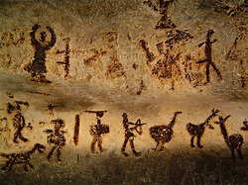
Some of the earliest visual records discovered are preserved on cave walls in Northern Australia and Lascaux in France. These cave paintings display images of hunters, animals, gods and people. Some of these images became so commonly used they formed the basis of our alphabet.
Visual language has a set of codes and conventions that influence the way we interpret different images. There are two types of images: still images and moving images.

Still images
- Posters
- Cartoons
- Photographs
- Billboards
- Illustrations
- Paintings

Guidelines for reading still images

Subject Matter
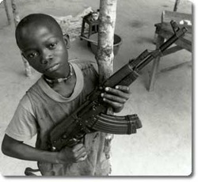
Begin by describing what you see. Describe the main elements of the image and explain the impact it has upon you as a viewer.
What do you SEE here??
- Boy
- Gun
- Tree
- Chair

Composition
The way the elements of the image are arranged in the frame is called composition. Which elements are the largest/smallest? Which elements are in the foreground/background? What is central to the image? Which elements are at the edges of the image? Elements that appear larger, in the foreground or centrally are often seen as important. Elements which are smallers, in the background or positioned near the margins seem less important or 'marginalised'.

Man your eskys!
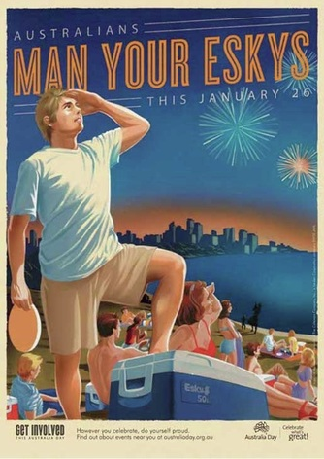
In this image the man is larger and in the foreground. Even though he is not in the centre of the image it is enough for us to consider the young white male to be the most important element in the image.
What is positioned in the centre is the esky. The esky is also positioned in the foreground which delivers a message to the viewer that an esky is particularly important for one reason or another. Although consumption of alcohol has been restricted at the Australia Day celebrations an esky is rarely used for hors d'oeuvres - here we slip into symbolism a little as an esky is used most often and represents Australian's connection to alcohol.
From this we can conclude that Australia values a white male society and that we are essentially a society of drinkers. Although this may not have been the intention of the creator, as a viewer it is our job to pull out the values and attitudes presented to us by dissecting these visual elements.

The Rule of Thirds
The rule states that an image should be imagined as divided into nine equal parts by two equally-spaced horizontal lines and two equally-spaced vertical lines, and that important compositional elements should be placed along these lines or their intersections.
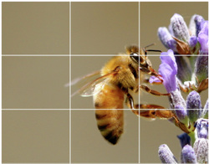
Aligning a subject with these points creates more tension, energy and interest in the composition than simply centering the subject would.
Here it appears as if the bee has flown from "somewhere", the left hand column of the image is 'blank'. This might tell a story rather than just being a photo of a bee.

.
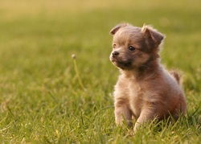
Here the puppy is placed to the right. It appears that he is looking at something out of the frame. Again, this may tell a story (What is he looking at? Is he going to run after something?) rather than being just a dog in some grass.

Leading lines
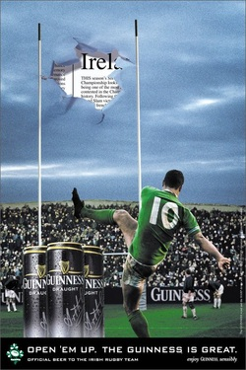
Images are composed of dots, lines and shapes. The eye is often drawn to the most important elements of the image through the use of 'leading lines'. These can include, but are not limited to, roads, horizons, fences, people pointing in a certain direction or objects arranged to draw your eye across the page. Lighting and shade lay also be used in a similar way.
In the image to the left, the first thing you might see is the tear in the sky.It is the whitest part of the image so they eye is immediately drawn toward it. If we follow the lines of the goal post to the bottom left of the image we can see the cans of Guinness. The cans are also conveniently framed by the legs of the rugby player. The bottom of the cans is lit from below which also draws our attention to, "Open 'em up. The Guinness is great. Official beer of the Irish rugby team".

Juxtaposition
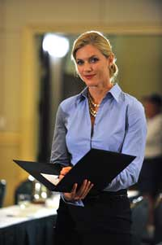
Juxtaposition:
1. an act or instance of placing close together or side by side, esp. for comparison or contrast.
2. the state of being close together or side by side.
In images juxtaposition means the relation of one element to another. If a woman is juxtaposed with a warm, inviting kitchen we would read that differently to and image where a woman is juxtaposed with an high powered boardroom.
The way we interpret an image also relies on the meanings different elements have in relation to one another.
Look at the images below. How does the juxtapositioning effect your interpretation of each relationship?

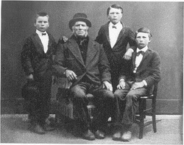 | 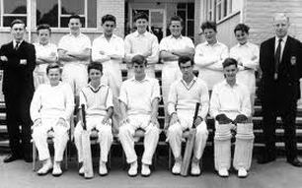
Notice how you interpret the proximity of the same people differently depending on the context of the image. Both images show a group of boys next to a man, or men. In the first image, we interpret this grouping as 'family'. The boys are dressed and arranged in the style of a family portrait and the body language (hands on shoulders, knees touching) adds to this interpretation. In the second image there are 12 boys and 2 men, therefore our interpretation is most likely 'team'. The context; cricket whites, the bat and shin pads, the number of boys, men who are likely coaches, support the cricket notion. The body language, arms crossed, hands on knees also supports the idea that it is a team photo rather than a portrait.

Colour

Colour has a great impact upon our viewing. As viewers we must determine which of the colours is most dominant. Is there is something in the image which then becomes more dominant, or important, as a result of being represented in this way? Consider the symbolic use of colour. What effect does an image have if it is in black and white? Consider the idea that not all black and white images are taken this way because the photographer simply couldn't afford colour, or the technology wasn't invented at the time. Often black and white images require the viewer to focus on shapes and textures rather than colour.

Lighting
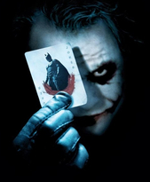
The way light is used in an image may result in some images being cast into shadow and some being highlighted. Light can increase the importance of an element or character. Shadows can be used to create an atmosphere of danger or suspicion. Lighting will, more often than not, affect your response to characters and other elements.
Look at the lighting in the image to the right. What interpretation is encouraged here by the shadows cast upon this character's face?

Symbolism
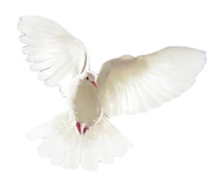
The objects in an image may have symbolic meanings in addition to their functional meanings. For example an apple is food (functional), but also love, desire, temptation and knowledge (symbolic).
Click here for more information on symbols.

Costume and make-up
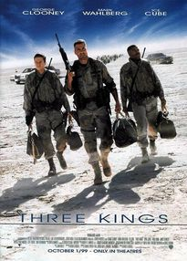
Clothing can suggest much about a character or person within an image. Look for outfits which either reinforce or challenge particular gender roles. For example; a woman wearing a feminine outfit, like an evening gown, shows that she conforms to the ideas surrounding gender expectations of women. If she is wearing a tuxedo instead she might be seen to challenge the expectations of her gender.
Uniforms also indicate something about the wearer. Soldiers and police officers wear a distinctive uniform which encourages a reading of power and control.
Make-up can be used in several different ways. Most commonly it is used to enhance the features of a female character or subject. Thick lips and long lashes emphasise femininity and reinforce a woman's adherence to gender expectations.
Make-up can also be used for effect or to create characters who otherwise couldn't exist. Scroll back to the image of 'the Joker'. Make-up is used to create this psychotic character and enhance his malevolent and violent nature. His make-up is not applied accurately and suggests that this character might be unhinged.

Props
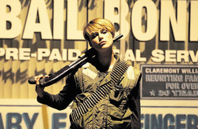
Props can also be considered symbols. Look at the image from Three Kings above; the men possess guns which indicates their control of the situation. A woman holding a gun might be seen to break the gender stereotypes associated with women and she may take on more masculine qualities.
The image of film character 'Domino', played by Kiera Knightly, to the right shows a female character in possession of a gun and ammunition. She appears to be confident and relaxed around this kind of weapon, however, she still wears make-up so, doesn't lose her femininity entirely.

Body language, gestures and facial expression
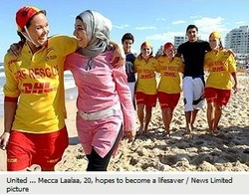
People presented in images and their posture or gestures will often provide some meaning for the reader. Posture will tell the reader much about a character and their possible role. If a character or person is standing upright, perhaps with their chin slightly raised, exuding confidence, we can assume that this person is dominant and has much of the power in the image. Look for body language which suggests a power relationship, or a relationship of equality, like the one to the left.
Gestures are mainly the domain of the hands which indicate a person's thoughts and feelings. They may be self-directed, like grooming or touching the face, or they may be directed at others, like slapping someone on the back or shaking a fist in rage.
You interpret facial expressions all the time probably without even knowing it. A smile, a quivering lip or a frown are easy ways of discerning how someone is feeling about a particular issue or situation. You might also consider the gaze of the person or character in an image. If someone is looking out of the frame it might suggest that they are deep in thought, disinterested in what is happening within the image and perhaps preoccupied with something we cannot see as a viewer. If the person is looking confidently and directly at us, we may feel confronted by the person within the image. If a person's body language suggests vulnerability, they may look at us but cover themselves in shame, embarrassment or try to protect themselves from our gaze.
For more information on the gaze, click here.

Action
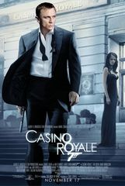
Action is fairly easy to interpret in film, but still images can also imply action. Even though still images are precisely that, still, they are able to capture a moment in time and it is up to the reader to suggest what may have happened before or after this image.
The image of James Bond to the right is a still image; however, there is a sense of movement as Bond walks towards the camera. There is a certain determination in his gait and his facial expression suggests he is on some kind of mission. His gun is at the ready and his jacket is flowing also, suggesting movement and a sense of direction.

Written codes
Just because you are analysing the visual elements of a text doesn't mean you should completely discount the written codes. Often the written text within an image will give you a deeper insight into its purpose or meaning. Consider the written codes evident on the image for Australia Day viewed above.

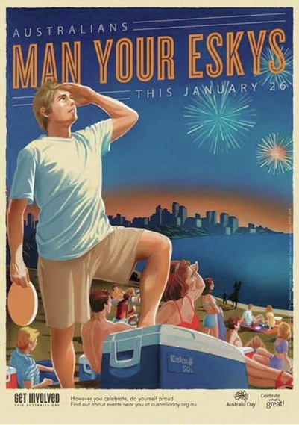

Australian's indicates inclusivity. It suggests that everyone who is Australian should be involved in this celebration.
Man your eskys is a play on words. Men in the military are often ordered to 'man your battle stations', indicating that Australia has fought for its freedom. It also links strongly to the ANZAC spirit and the image of the man reinforces this idea. This is interesting as it excludes women, either deliberately or not and suggests that Australia is a patriarchy.
Get involved this Australia Day. Again the call to be involved in this celebration is reiterated. It is very important that we show our patriotism.
However you celebrate, do yourself proud. Australia Day is all about being proud of our fine nation, the man saluting to the sky complements this idea. It also subtly reminds Australians, who are very fond of drinking, to take it easy with the booze. 'Do yourself proud' ie: don't do anything stupid because you're drunk.
Celebrate what's great!. By the time we get to this I think it's pretty clear how the creator, or whoever commissioned the advertisement, feels about Australia. The exclamation mark further reinforces the enthusiasm surrounding this notion.
As you can see, the written conventions wholeheartedly support the visual conventions and provide support for any argument you may provide about the elements of the image

